|  |  |  |  |
| --- | --- | --- | --- |
| Minnie | Mickey | Goofy | Donald |

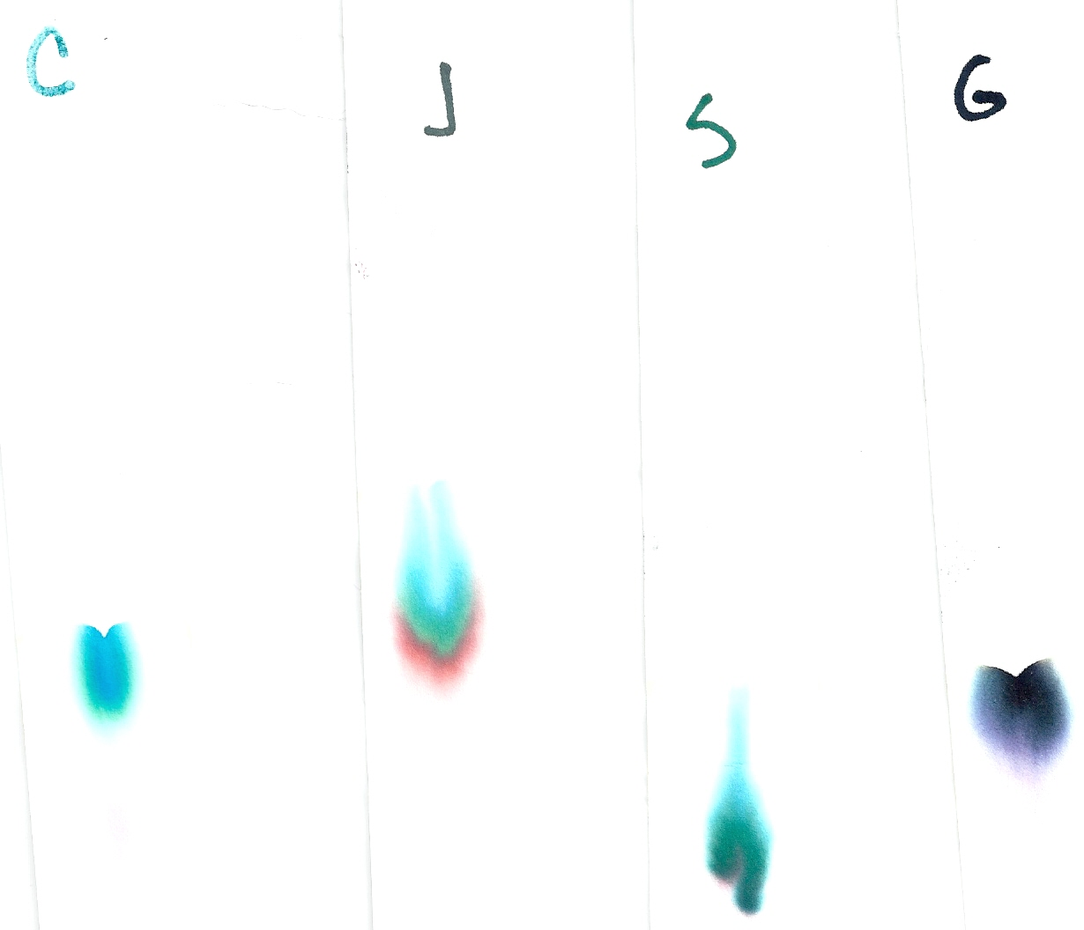

Paper Chromatography was conducted on some of the suspects favorite pens that they are known to use. The pens were found on the suspects and matched to the note. Identify the suspect’s Pen. Be sure to attach your matching chromatogram to your test when you turn it in.